# Task 3 - Backup Configuration for Web Servers

Objective: Configure automated backups for Sarah’s Apache server and Mike’s Nginx server to ensure data integrity and recovery.

* Sarah is responsible for managing an Apache web server.

1. Prepare the Backup Directory - Created the folder for backups.

sudo mkdir -p /backups

sudo chmod 700 /backups

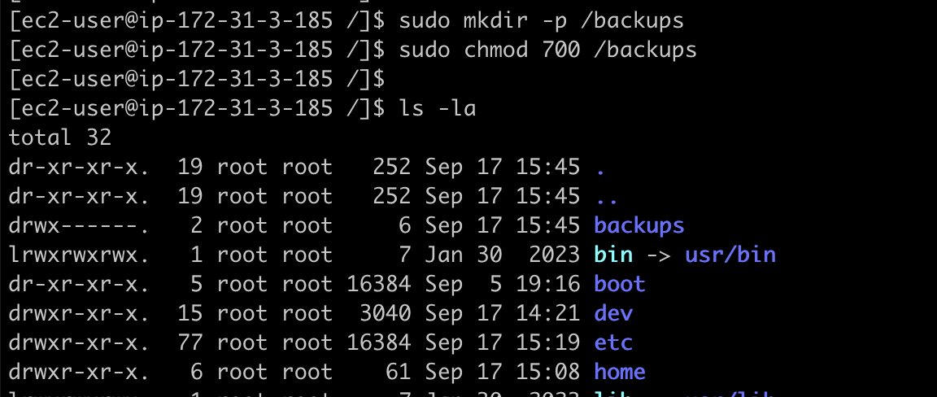

1. Create the Backup Scripts

(A) Sarah’s Apache Backup Script

Create the script:

sudo nano /usr/local/bin/apache_backup.sh

Added the below lines run the backup script in “apache_backup.sh”

#!/bin/bash

DATE=$(date +'%Y-%m-%d')

BACKUP_DIR="/backups"

ARCHIVE="${BACKUP_DIR}/apache_backup_${DATE}.tar.gz"

VERIFY_LOG="${BACKUP_DIR}/apache_backup_${DATE}_verify.log"

mkdir -p $BACKUP_DIR

tar -czf $ARCHIVE /etc/httpd/ /var/www/html/ 2>/tmp/apache_backup_error.log

tar -tf $ARCHIVE > $VERIFY_LOG 2>>/tmp/apache_backup_error.log

Once updated save and exit the script. Run the blow command to test the backup script.

sudo chmod +x /usr/local/bin/apache_backup.sh

Mike’s Nginx Backup Script: /usr/local/bin/nginx_backup.sh

#!/bin/bash

DATE=$(date +'%Y-%m-%d')

BACKUP_DIR="/backups"

ARCHIVE="${BACKUP_DIR}/nginx_backup_${DATE}.tar.gz"

VERIFY_LOG="${BACKUP_DIR}/nginx_backup_${DATE}_verify.log"

mkdir -p $BACKUP_DIR

tar -czf $ARCHIVE /etc/nginx/ /usr/share/nginx/html/ 2>/tmp/nginx_backup_error.log

tar -tf $ARCHIVE > $VERIFY_LOG 2>>/tmp/nginx_backup_error.log

Once updated save and exit the script. Run the blow command to test the backup script.

sudo chmod +x /usr/local/bin/nginx_backup.sh

1. Cron Job Configuration

Schedule both scripts to run every hour at 0 minutes

Use sudo crontab -e and add:

0 * * * * /usr/local/bin/apache_backup.sh

0 * * * * /usr/local/bin/nginx_backup.sh

1. Verification of scripts

Backup files will be named for both Sarah and Mike, as in the /backups folder:

/backups/apache_backup_YYYY-MM-DD.tar.gz

/backups/nginx_backup_YYYY-MM-DD.tar.gz

